Year 1 – Homework: 18.5.26
Learning Platforms | Spellings
Your login details for Bug Club and Numbots are in the back of your home-school diary.  Please read the books set for you on Bug Club as part of your weekly homework. Also, please spend some time on Numbots to practise your maths skills.  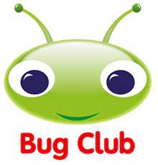 | Practise your weekly spellings using look, cover, spell, check or ask someone to test you by reading them aloud whilst you write them down.  Your spelling test will be on Tuesday.    Complete Watch How animals grow. 2Do on purple mash.
  Key words | Sound words
  school  these  because  plant  ask | astronaut  author  pause  dinosaur  August
Homework Books
Complete page 6 and 7 of your Scofield and Sims maths book.
Complete pages 38 and 39 of your Scofield and Sims phonics book 5.

Year 1 – Homework: 18.5.26
Learning Platforms | Spellings
Your login details for Bug Club and Numbots are in the back of your home-school diary.  Please read the books set for you on Bug Club as part of your weekly homework. Also, please spend some time on Numbots to practise your maths skills. | Practise your weekly spellings using look, cover, spell, check or ask someone to test you by reading them aloud whilst you write them down.  Your spelling test will be on Tuesday.  Complete Watch How animals grow. 2Do on purple mash.
  Key words | Sound words
  school  these  because  plant  ask | astronaut  author  pause  dinosaur  August
Homework Books
Complete page 6 and 7 of your Scofield and Sims maths book.
Complete pages 38 and 39 of your Scofield and Sims phonics book 5.

